**Free Pre-K in 3 Simple steps for eligible* children**



**Step 1:** Fill out the attached application

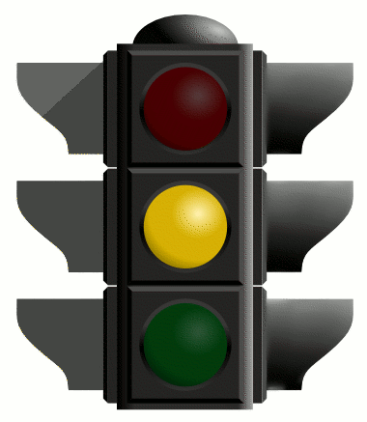

**Step 2:** Bring all documents to open enrollment.

(See Document checklist & Open Enrollment times)

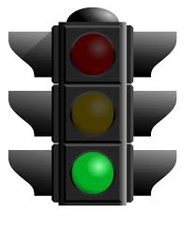

**Step 3:** Pick a provider from the attached list.

Applications will be processed on a first come, first served basis. Applicants must complete all steps with River Valley Resources before a grant can be awarded. All steps must be completed by July 31st, 2015 to receive an On My Way Pre-K grant. Applications are not guaranteed to be accepted through July 31st 2015. Funding is limited and the award of a grant is dependent on the available funding. Once available seats are filled program enrollment will end.

*Applicants must meet income eligibility and live in Jackson County to qualify. Children must be 4 years old and not yet 5 by August, 1st 2015.

**Schedule for Open Enrollment**

All applicants must attend a face-to-face appointment with the intake agent, River Valley Resources, during one of the open enrollment times listed below.

Open enrollment will be held at Jackson County Learning Center, 323 Dupont Drive in Seymour. The length of the appointment will vary but please allow at least 30 minutes. For quicker service appointments are available, but appointments are not required.

Applicants must bring all of the required documentation to open enrollment (see attached list) before a grant can be awarded. All documentation must be received by July 31st.

**If you have questions or wish to make an appointment please call River Valley Resources at 855-591-7848.**

|  |  |  |
| --- | --- | --- |
| **Dates** | **Open** | **Close** |
| July 9th | 10 AM | 4 PM |
| July 10th | 10 AM | 4 PM |
| July 14th | 10 AM | 6 PM |
| July 15th | 10 AM | 6 PM |
| July 16th | 10 AM | 6 PM |
| July 21st | 10 AM | 6 PM |
| July 22nd | 10 AM | 6 PM |
| July 23rd | 10 AM | 6 PM |
| By appointment ONLY July 27th- 31st | | |
| **Open Enrollment Location:**  Jackson County Learning Center  323 Dupont Drive Seymour, IN 47274 | | |

